LEARNINGS

Python Learnings:

ByteArray

A byte is 8 bits (binary data).

A byte array is an array of bytes .

You could use a byte array to store a collection of binary data, for example, the contents of a file. The downside to this is that the entire file contents must be loaded into memory.

For large amounts of binary data, it would be better to use a streaming data type if your language supports it.

NUMPY

NumPy is a Python library.

NumPy is used for working with arrays.

NumPy is short for "Numerical Python".

It also has functions for working in domain of linear algebra, fourier transform, and matrices.

The array object in NumPy is called ndarray

## Creating a ndarray object

a = numpy.array

Indexing

Slicing

Reshape

Max,min,sum

Concat – vstack, hstack

# NumPy Datatypes

arr = np.array([1, 2, 3, 4], dtype='i4')

newarr = arr.astype('i')

* i - integer
* b - boolean
* u - unsigned integer
* f - float
* c - complex float
* m - timedelta
* M - datetime
* O - object
* S - string
* U - unicode string
* V - fixed chunk of memory for other type ( void )

**import** numpy as np

d=np.dtype([('salary',np.float)]) #floatType array

arr = np.array([(10000.12,),(20000.50,)],dtype=d)

**print**(arr['salary'])

**PANDAS**

**-----------------------------------------------------------------------------------------------**

Like glue functionality, there are tools to perform ETL functionalities. ETL tools are categorized

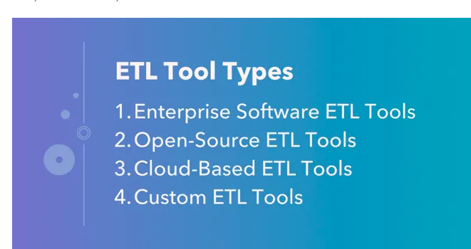

# SNAPLOGIC

SnapLogic is often categorized as an **ETL** (Extract, Transform, Load) tool. ETL tools are used for data integration, where they facilitate the extraction of data from various sources, the transformation of data into the desired format, and the loading of that data into a target destination such as a data warehouse, database, or another system.

SnapLogic is used for **data integration** and workflow automation, allowing organizations to **connect different data sources,** systems, and applications, and create efficient data pipelines. It is more focused on improving data connectivity and automation within an organization

SnapLogic is a **Cloud-Based ETL Tools**

The price you pay is predictable and easy to budget.

An area where we have a form of variable pricing is with our [API processing](https://www.snaplogic.com/products/api-management-development).

Snaplogic is a **integration** platform as a service

IT supports all types of integrations like cloud-to-cloud, cloud-to-ground, ground-to-ground.

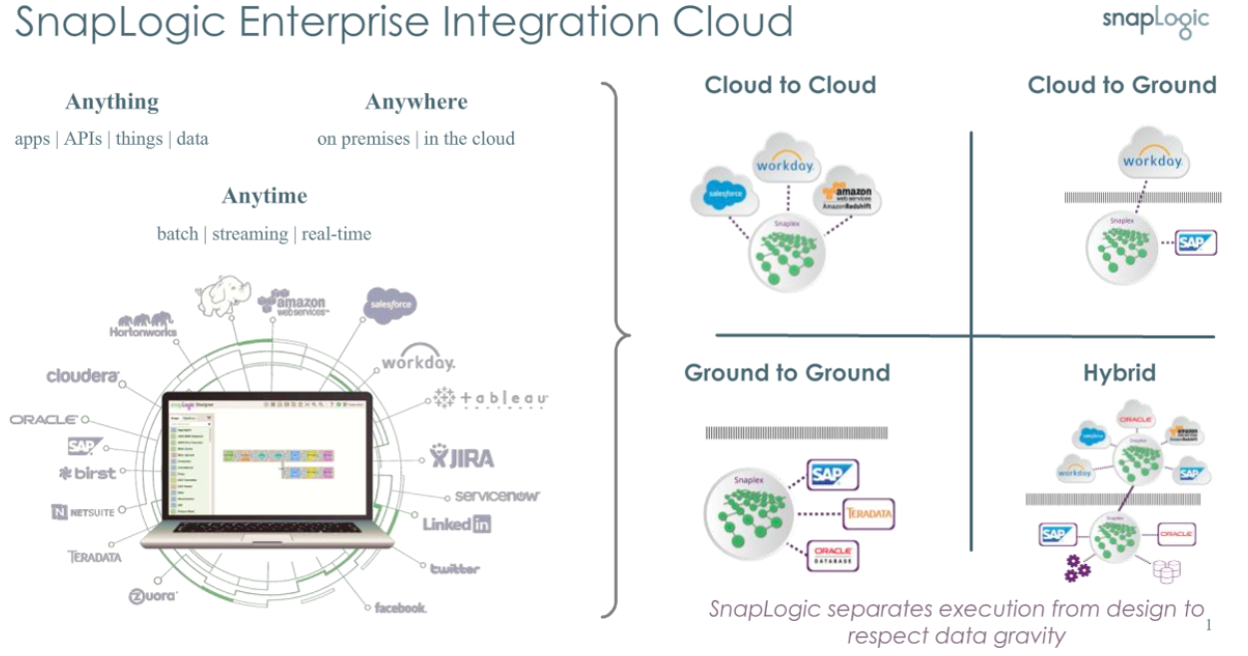

Architecture of SnapLogic

1.Platform - html web pages. Helps to design, manage & monitor integration

2.Snaplexes - execution area, data processing engines.

Snaplex is a runtime environment for Pipelines.

Snaplex can be a Cloudplex ([SnapLogic Managed](https://docs-snaplogic.atlassian.net/wiki/spaces/SD/pages/1902773616)) or a Groundplex ([Self-managed](https://docs-snaplogic.atlassian.net/wiki/spaces/SD/pages/1438278)).

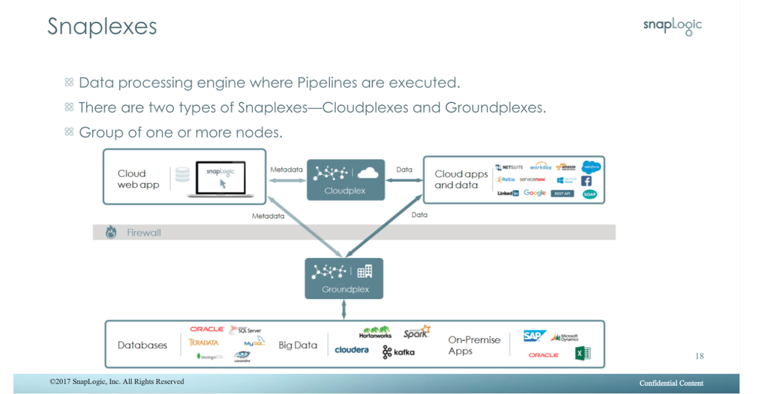

A Snaplex is the data processing engine of the SnapLogic platform.

It is made up of **nodes, nodes are containers, or virtual machines** or real hardware based servers.

A minimum of two nodes per Snaplex are required for production use.

A Snaplex is only available to one org It is horizontally and vertically scalable, to add more capacity, add more nodes, or increase the node size.

When it is provided by SnapLogic as a service it is a Cloudplex .

Cloudplexes are single tenant and single org

When it is located in the customer domain it is called a Groundplex

Customers download a container, or provision virtual machines or ?real?servers to host the SnapLogic application

Once installed Groundplexes are managed remotely by the SnapLogic Control Plane

3.Snaps - provides operations to integrate with diff application . Snaps are pre-built connectors for different applications and data sources.

snaps can be combined to create integration pipelines that move data between systems and perform various data transformations.

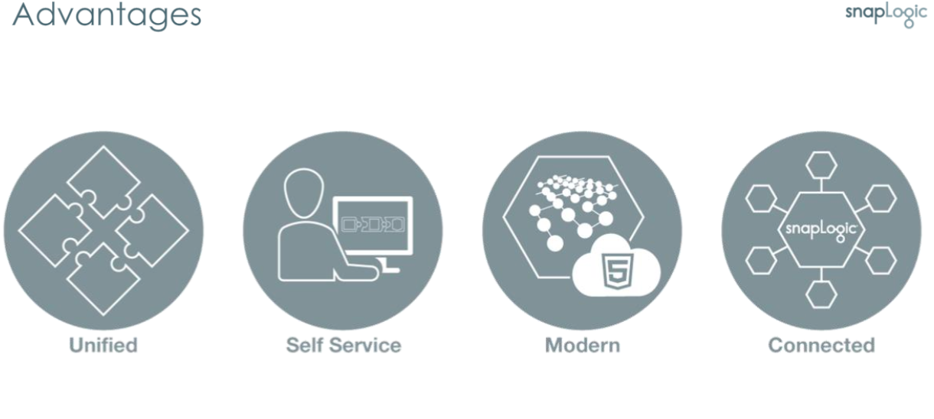

SnapLogic has pre-built AI iris & integration assistant that recommend using snaps

KEY CONCEPTS:

1.Snap - computational unit that performs operation that process data

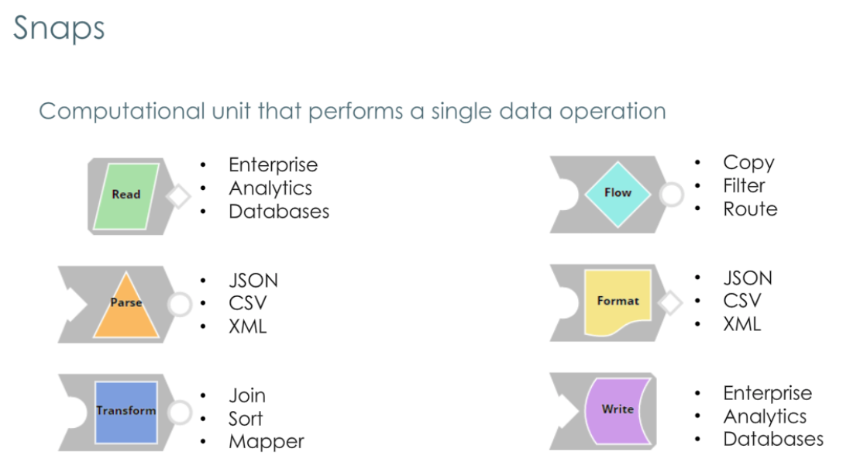

2.Snap packs – it is collection of snap. Snaps are locked within a packs

Three types of packs – core,premium & custom

Core – data transformation & endpoints

Premium – social, data, analytics. Enterprise

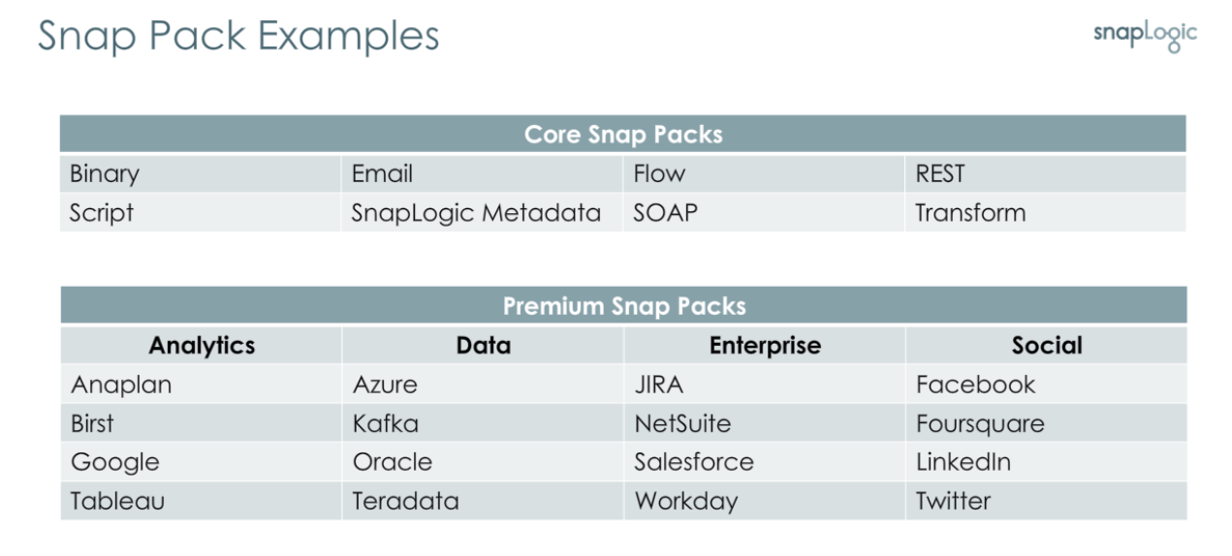

3.Pipelines

Pipelines are created by connecting set of snaps

Define the logic of data processing in data transfer

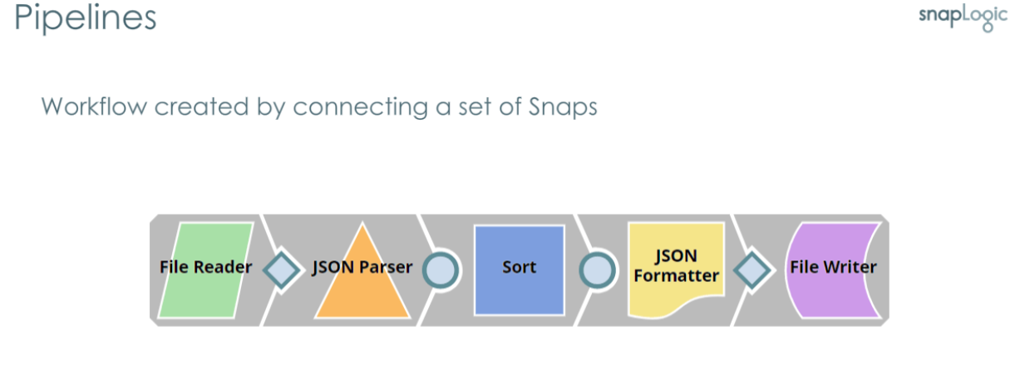

4.Patterns - Patterns are resuable templates used to create pipelines

5.Tasks - Enables to execute pipelines

Three types of tasks – triggered, scheduled & ultra task for low-latency processing

6.Snaplexes - data processing engines where pipelines are executed . It process & stream data between application. Two types – 1.cloud plex – that run on cloud & managed by snapLogic admin

2.GroundPlex – runs on server managed by client

* **Groundplex:** This is an on-premises deployment of Snaplex, which means it runs within an organization's own data center. It allows for the integration of data from on-premises systems.
* **Cloudplex:** This is a cloud-based deployment of Snaplex, designed to integrate with cloud-based applications and services. It facilitates the integration of data in the cloud.

Each snaplex made of one or more nodes.

7.Nodes - Node is a host or a server run on windows/Linux with snapLogic application installed. snapLogic application runs on JVM.

8.Organizations(orgs) - Each tenant represents the organization. Most customers use 3 organization development, testing & production

9.Subscription features – ultra task & Enhanced account encryption with security

Lesson - platform overview & managing assets

SnapLogic platform consisits of html components

To login elastic.snaplogic.com

DESIGNER -

MANAGER - create & manage user,security, project & project spaces.Manage security,sso , password expire policies

DASHBOARD - functionality in dashboards based on user permissions

It monitors pipeline

Dashboards comprise of Health wall, pipeline wall, snaplex wall, Insights wall

Health wall - monitor pipeline & snaplex health, enables restart nodes

pipeline wall - displays pipeline, execution history,execution details,execution status

Snaplex wall - view snaplex statistics, displays graph for active pipelines,executed pipelines

Insights wall - displays timeseries data, retrieve logs from runtime database to generate user activity graphs.

CREATING & MANAGING WORKSPACE & PROJECTS:

Project space & project enables to organize assets in manager. Create project space & prjects from manager.

Project space consists of one or more projects

Projects used to store all related acc, files ,tasks , pipeline, snap packs & snaplexes

Naming conversion for creating project Camel case(helloWorld), no spaces & alphanumeric eith underscores

-----------------------------------------------------------------------------------------------------------------------------

CREATING & MANAGING PIPELINES

To create pipeline:

1. Add a pipeline

2. Add snaps - represents documents/File, represent binary data

3. Configure snaps

4. Link snaps – output (doc) -input(doc)

5. Save pipeline

Validate

------------------------------------------------------------------------------------------------------------------------------------

Lesson_Expression Language in Snaps

Expression language:

Write expression to transform & manipulate data based on Javascript

Used in snaps (filter, router, mapper)

Use parameter & fields to interact data

PARAMETERS:

Enable dynamically pass inputs with invoking pipelines

Variable value remains unchanged during pipeline execution

Parameter – key value pairs. Key contains only alpha-numeric

FIELDS:

Field are metadata when data been processed.

For Document input – fields & parameter are used in snaps

For Binary input – only parameters are used in snaps

Expression functionality only for string properties, Expression builder to write complex expression

$filename for flat files.

OPERATORS

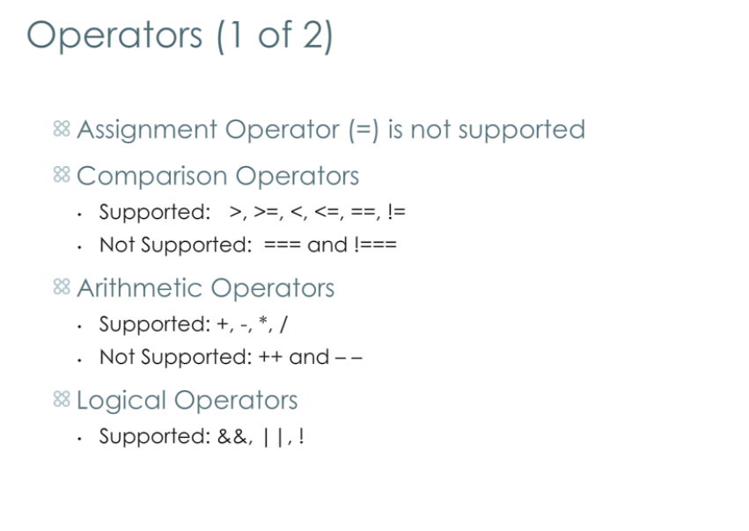

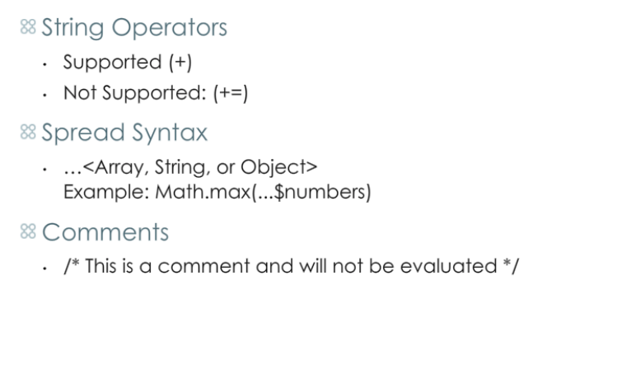

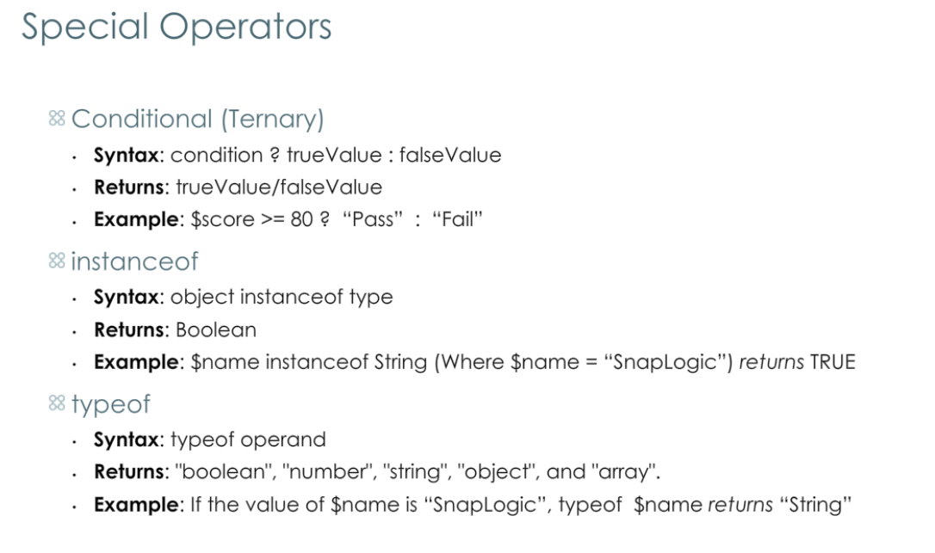

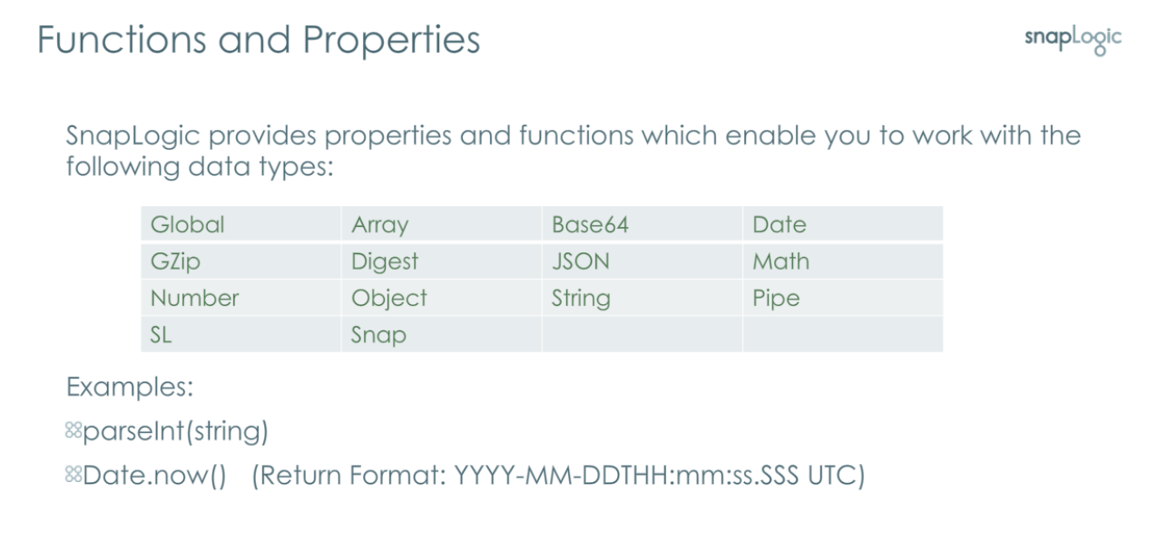

FILTER SNAP:

Filters data based on Boolean value

ROUTER SNAP :

It is designed to handle multiple data views

JSON Path:

Used in json splilter & mapper snaps

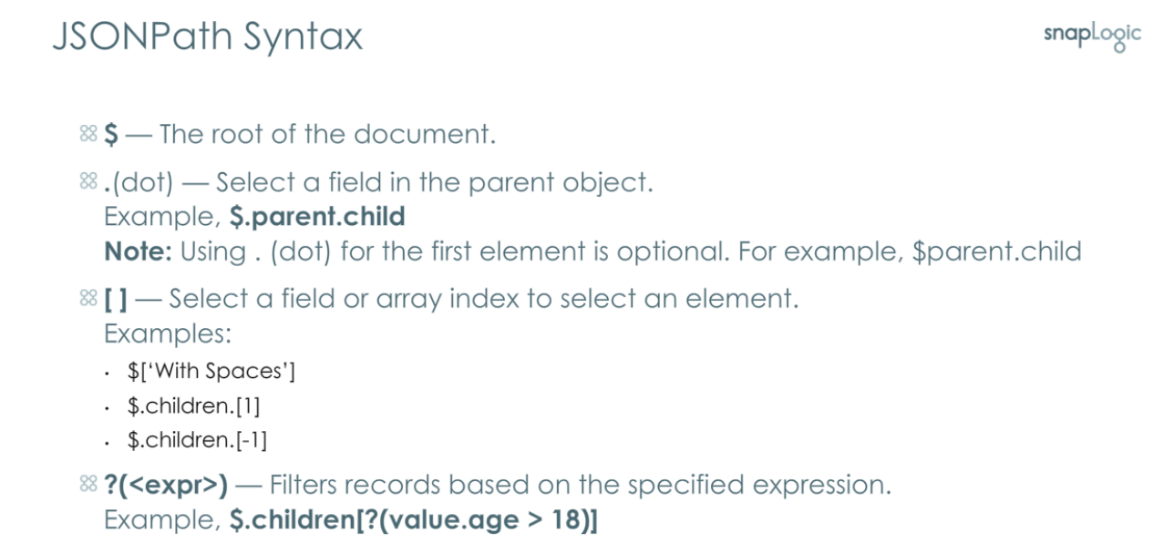

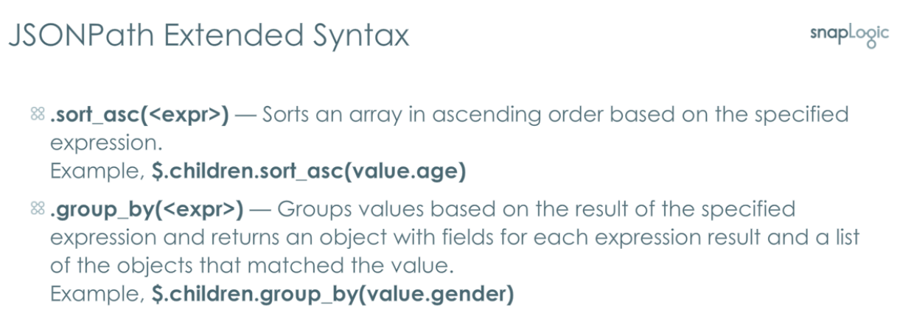

BEST PRACTICE in expression:

Externalize environmental variable as parameter to allow modification during pipeline invocation

Add comments for complex expression

-----------------------------------------------------------------------------------------------------------------------------------

Lesson_CREATING & MANAGING TASK

Task –executing task can be done by

1. Triggered task
2. Scheduled task
3. Ultra task

**Triggered task:**

Enable you to create URL  
Basic authentication

Support token authentication

Passing input & viewing output.

The response of the triggered task is in the form of JSON. Can also change the formatter as we wish

**Scheduled task:**

* Create tasks, select schedules with starting time with repeated specific time.
* Manage task in manager tab.

**BEST PRACTICE:**

* Use meaningful names
* Do not start a new execution, if already is active
* Avoid using space in triggered task
* Set concurrent API limit
* Avoid exposing large or time-consuming pipelines in triggered task instead you can use async processing pipelines.
* Enable email notification
* Use local URL to execute triggered task

------------------------------------------------------------------------------------------------------------------------------------------

LESSON_MODULARIZING & REUSING PIPELINE

* Pipelines execute snap
* Rest get & rest post snaps
* Patterns
* Error pipeline

BEST PRACTICES

Modularize based on functionality & avoid deep nesting without purpose

Design child pipeline to execute for less than 15min

Use format z_< pipeline name > when naming child pipeline

Use pipeline execute snap over rest snap

Rest snap can be used when pipeline is in another project directory

Avoid triggering chain reaction

Use Json document to pass data between pipeline instead of parameter

Increase pool size when using pipeline execute snap

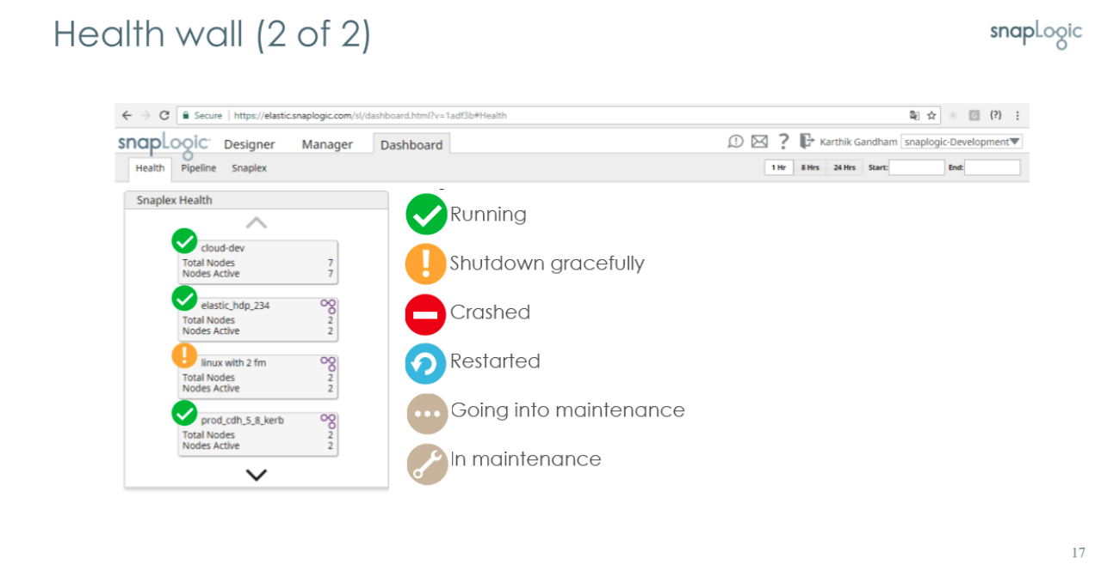 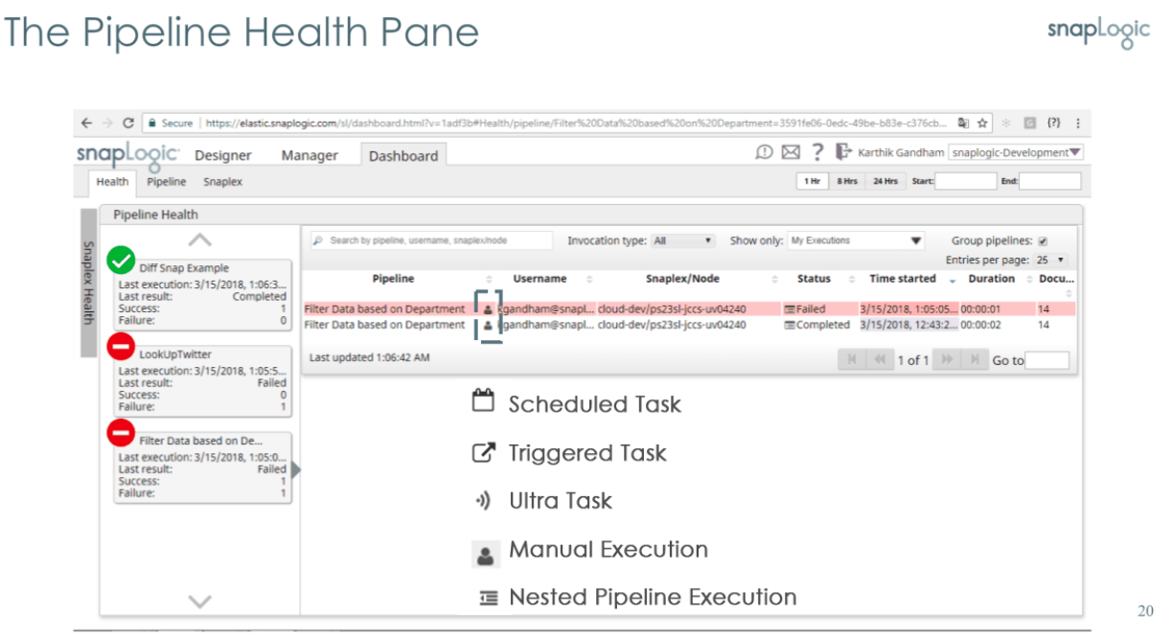

Competitors or alternative to snaplogic

* Workato.
* Informatica Intelligent Data Management Cloud.
* Power Automate.
* Boomi.
* Celigo Integration Platform.
* Cloud Workflow.
* SAP Integration Suite.
* TIBCO Integration.

----------------------------------------------------------------------------------------------------------------------------

ANAPLAN:

It is connected financial & business platform

Web based enterprise platform(cloud)

Analyzing & planning can be done using this platform in organizational level

1. Writing Documents to Anaplan_UC1

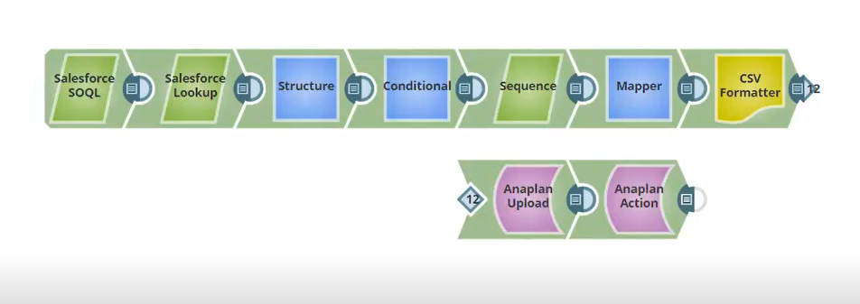

2. Writing Record Documents From Workday to Anaplan_UC2

This pipeline reads journal from workday & write into Anaplan

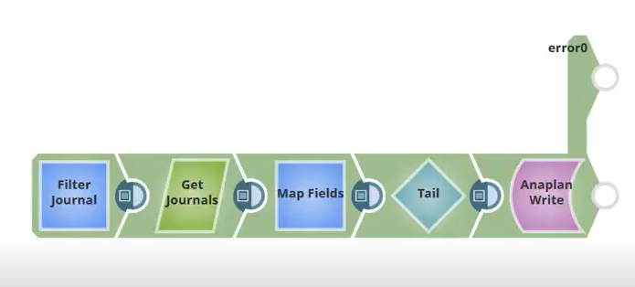

3.Writing Data From SAP to Anaplan_UC3

Reads from Sap & write into Anaplan

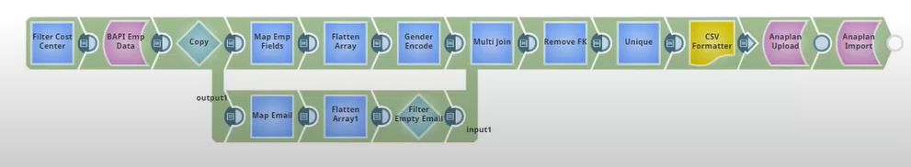

4. Migrating Data From one Anaplan Model to Another_UC4

Migrate data from one anaplan to other anaplan

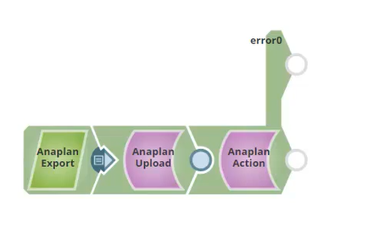

JDBC

Writing Data Using Generic JDBC Snaps UC 1

Reading data from Salesforce & writing data into redshift

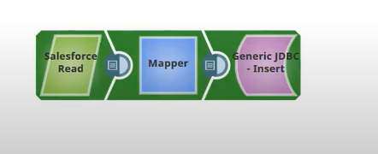

Updating Data Using Generic JDBC Snaps UC 2

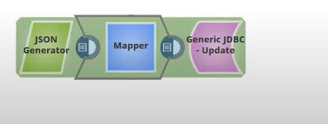

Reading Data Using Generic JDBC UC 3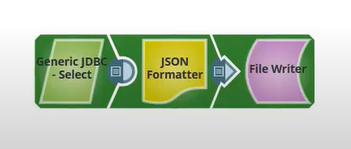

Deleting Records Using Generic JDBC UC 4

Use execute JDBC snap & write del query to del from db

-------------------------------------------------------------------------------------------------------------------------------

JSM

JMS stands for Java Message Service, and it is a Java-based messaging standard for exchanging messages between applications.

It allows you to send message point-to-point(queue) & publish-subscribe (topics)

Writing Messages to a JMS Queue UC 1

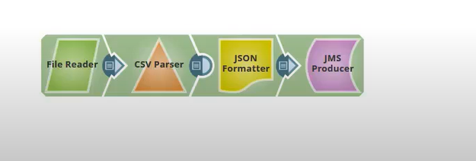

------------------------------------------------------------------------------------------------------------------------------------

NETSUITE

NetSuite is the most used cloud enterprise resource planning

We can use NetSuite snap – to create,update,del records

Get records or list of records

Search records

SnapLogic supports the integration of **on-premises** data sources. This capability is provided through the use of Snaplex, which can be deployed in an on-premises environment as "**Groundplex**."

Groudplex should download snaplogic package, configuration file and java source in on premises environment. Once it is done, we can be able to connect on premesis source data with snaplogic

Refer: <https://www.youtube.com/watch?v=CvbtMRfurlQ&t=106s>

Who can create & modify snaplex

Note: Only organiztion admin & the user whose role is accessibe to create snaplex

Only **Org admin** to view and change the values of a Snaplex. The one exception is if you created the Snaplex. If your SnapLogic user account was created with **Provision this user as a developer** option selected, then you are the owner of that Snaplex, and you can make changes to the Snaplex settings.

Storage Gateway – AWS **Storage Gateway** connects on-premises environments with cloud storage through cached volumes, stored volumes and tape-based backup. Here we cannot connect samba becaze it shared location still runs on the local machine. Whatever the file we have in configured location it will go onto the AWS resource configured .eg. S3

# easy EBS sharing

------------------------------------------------------------------------------------------------------------------------------------------

LOAD BALANCER

A load balancer provides the efficient network distribution or application traffic between client devices and backend servers.

In a SnapLogic-managed Snaplex (Cloudplex), a load-balancer might be configured already.

Usecase where load balancer use:

* 1. For Triggered Tasks, you only need to configure the **Load balancer** field.

1. For direct API calls to the Snaplex, the requests must pass through a load balancer.

------------------------------------------------------------------------------------------------

Ultra pipeline

Pipeline executes multiple instances of a pipeline are running always.It provides load balancing & low latency processing

Architecture

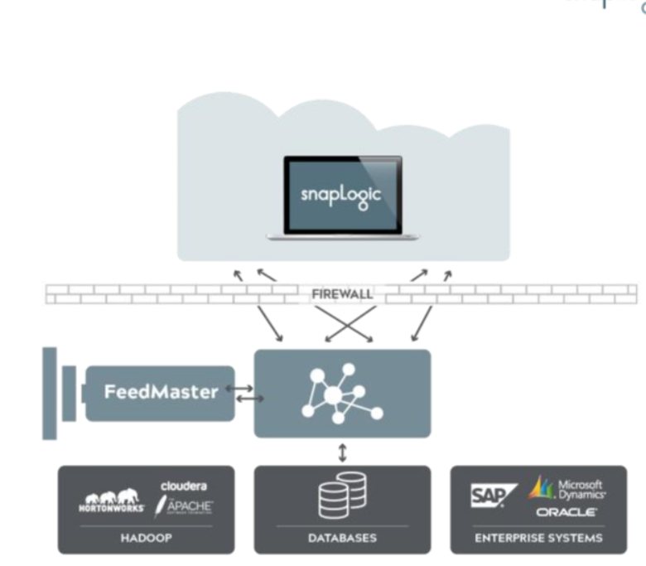

Ultra task uses feedmaster to execute pipelines

Feedmaster is a java virtual machine act as a interface between nodes & clients

------------------------------------------------------------------------------------------------

Script snap

can yu decribe when and how to use script snap with python language

Here are some tips on when and how to use the Script Snap with Python:

### When to use

* When you need to run custom Python code as part of your pipeline logic
* For data transformations or preparations that are not supported out-of-the-box by other Snaps
* To integrate with external Python libraries or call Python functions

### How to use

* Import required Python modules at the top of the script
* Declare any global variables under global_variables
* Write data transformation/preparation logic in the execute() method
  + Read input documents using self.input.next()
  + Write output documents using self.output.write()
* Access pipeline context like input, output, error and log using self.input, self.output, self.error, self.log
* Use built-in SLToolkit module for utility functions like downloading files
* Add error handling using try/except blocks and log messages
* Optionally write cleanup logic in cleanup() method
* Return the script object from a hook() method
* Use Python native data types and convert to/from SnapLogic document data types

So in summary, the Script Snap with Python is useful for running custom Python logic as part of a pipeline. Make use of its hooks and pipeline context objects within the script to integrate it with the rest of the pipeline.

what is hook()? Is there any standard template to write logic in script editor? if so provide those details

Here are some details on the hook() method and template for writing logic in the Script Snap:

# hook() Method

The hook() method is the main entry point for executing logic in a Script Snap. When a document is passed to the Script Snap, the Snap runtime will call the hook() method, passing the document as a parameter.

The hook() method typically follows this structure:

def hook(doc):  
 # Read input document  
 input = hook.input  
  
 # Execute business logic   
 output = transform(input)  
  
 # Write output document  
 hook.output.write(output)

So the hook() method is where you read the input document, execute any transformations or business logic, and write the output.

# Template

A standard template for writing logic in the Script Snap may look something like:

import hook  
  
# Custom functions  
def transform(input):  
 # Transform logic here  
 return output  
  
# Main hook method   
def hook(doc):  
  
 input = hook.input  
 output = transform(input)  
  
 hook.output.write(output)

The key aspects are:

* Import the hook module
* Define any custom functions
* Implement the hook() method to read input, call functions, and write output

This provides a clean separation of the main hook logic and any reusable functions.

So in summary, the hook() method is the entry point that gets called by the runtime, and you define your business logic by reading input, calling functions, and writing output within hook().

Is hook() has python libraries? If not how can I import python libraries to transform data

The Script Snap in SnapLogic allows you to write custom Python code to transform data within a pipeline. The hook() method provided in the Script Snap already imports some common Python libraries like json, math, datetime etc.

If you need additional Python libraries, you can import them at the top of your Python script code. For example:

import pandas as pd  
import numpy as np  
  
from com.snaplogic.scripting.language import ScriptHook  
  
class TransformScript(ScriptHook):  
 def __init__(self, input, output, error, log):  
 ...  
  
 def execute(self):  
 ...  
 #use pandas, numpy etc  
 df = pd.DataFrame(data)   
 ...

So in summary:

* The hook() method provides some common Python imports out of the box
* You can import additional libraries as needed at the top of your custom Python code
* Then use those libraries as normal within your execute() method

Let me know if you have any other questions!

------------------------------------------------------------------------------------------------Snaplogic CI/CD

Continuous integration & continuous delivery

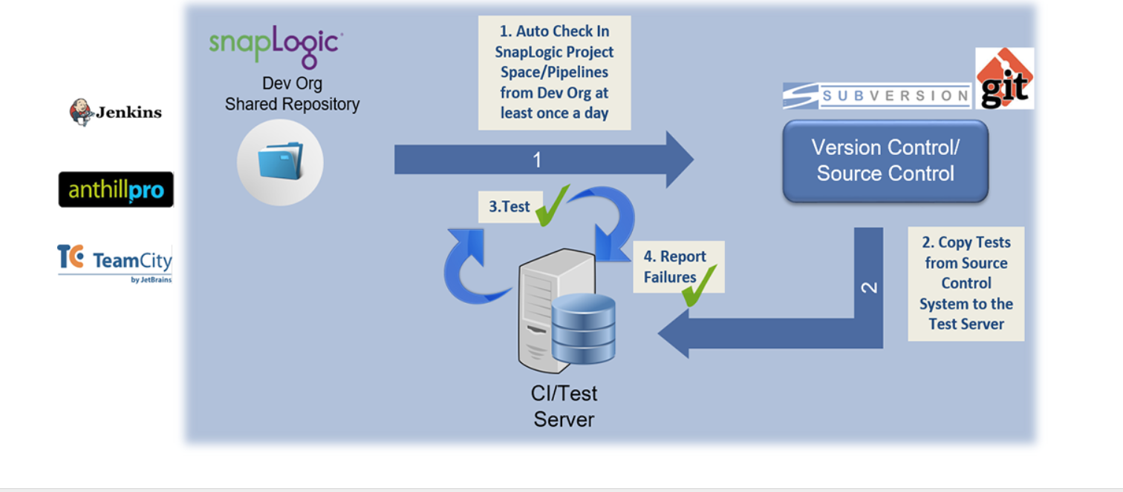

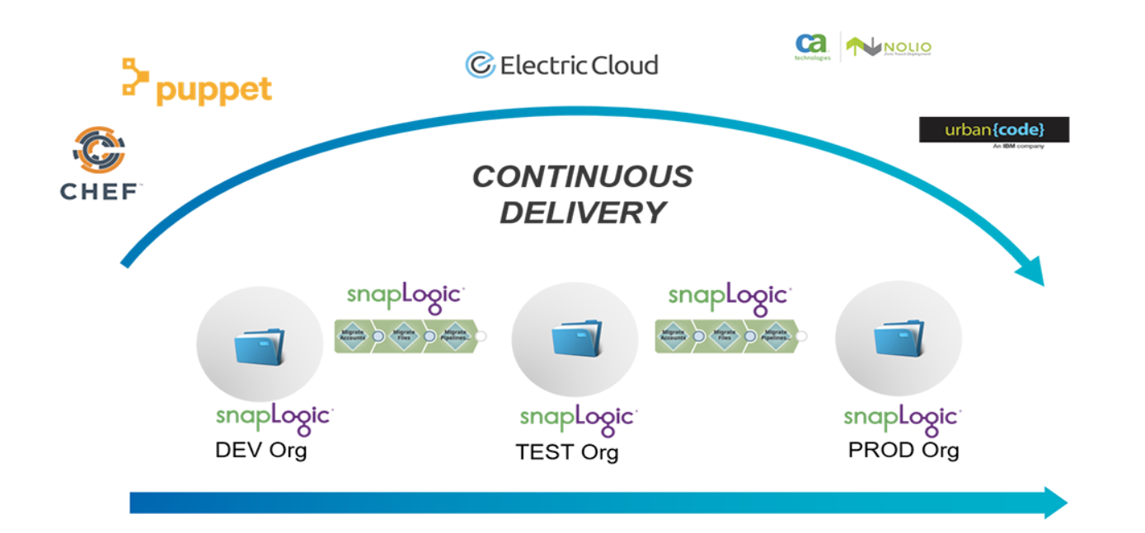

Organization Structure

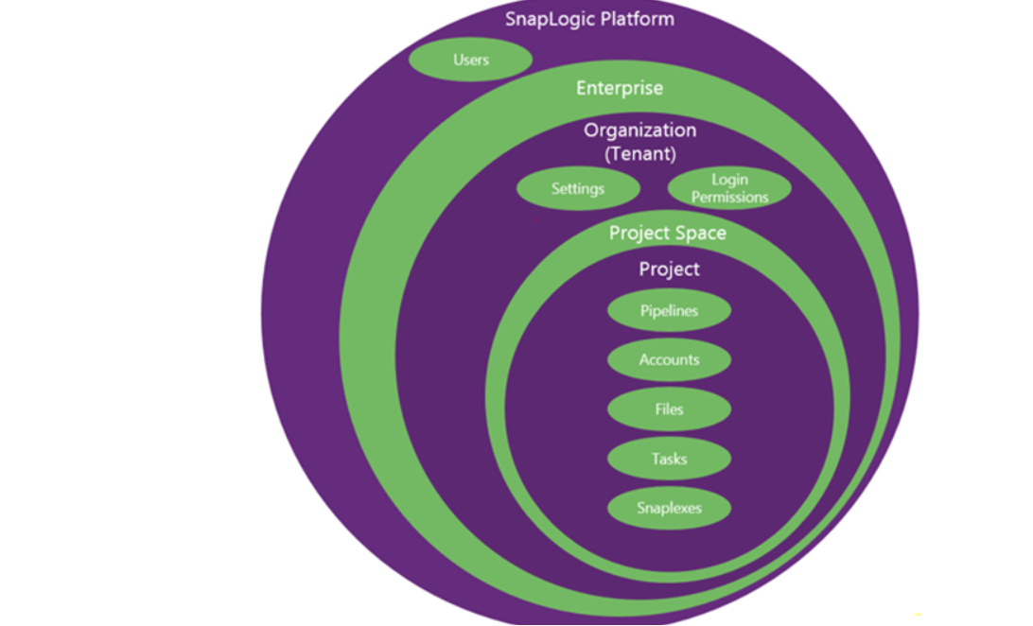

Implementation

Organization as environment

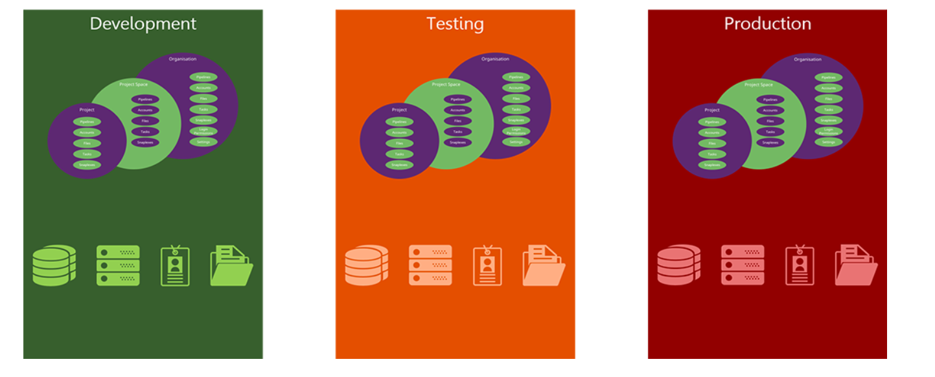

All the continuous development done in dev orgs through pipeline in pipeline

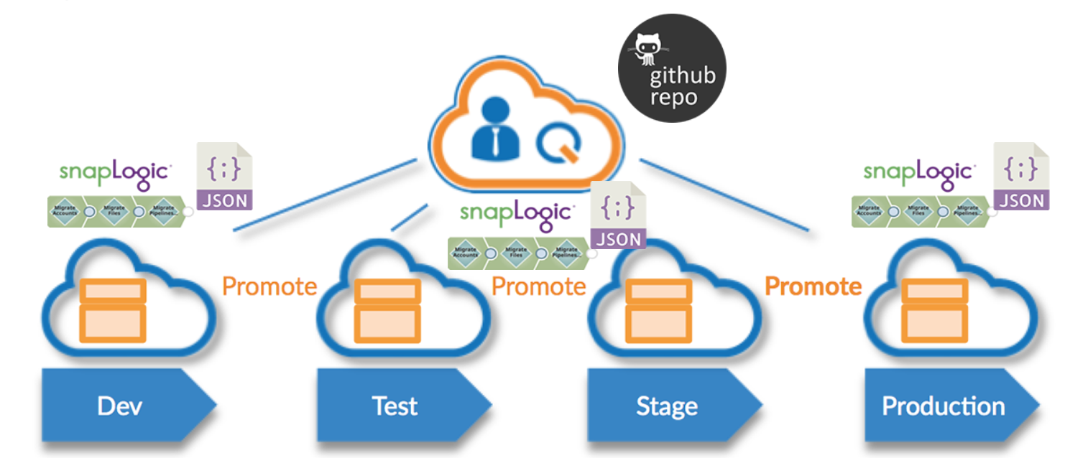

Deploying integrations between environment

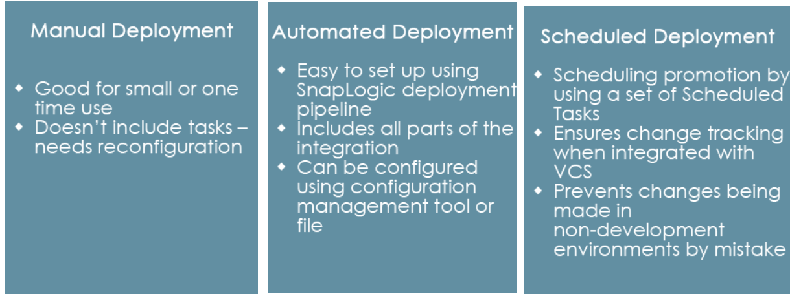

--------------------------------------------------------------------------------------------------------------------------

Hands on –1

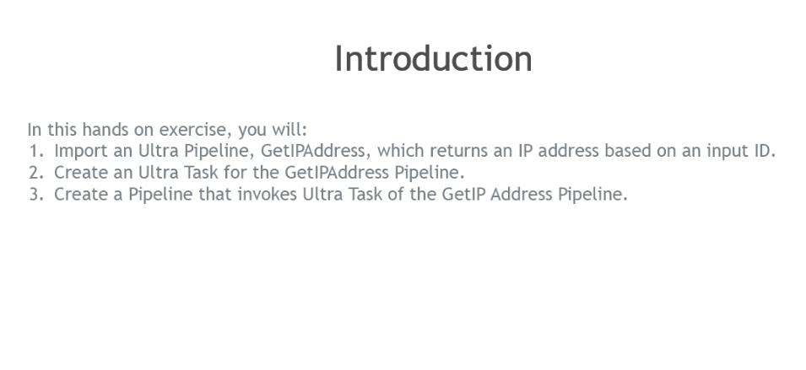

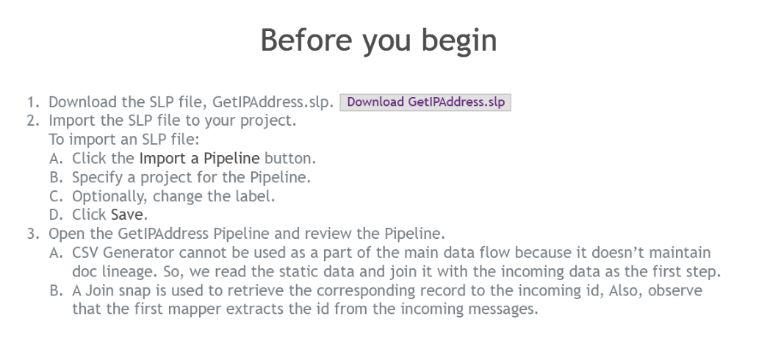

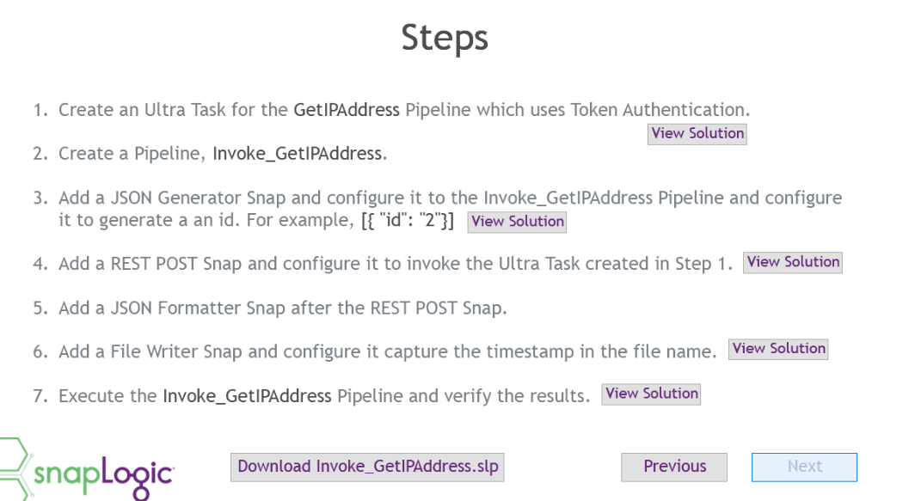

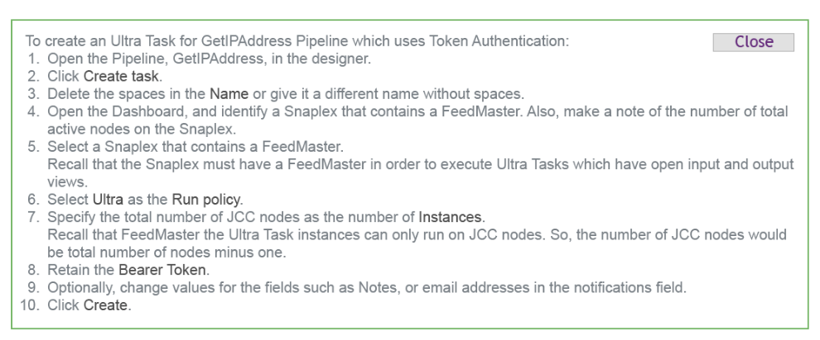

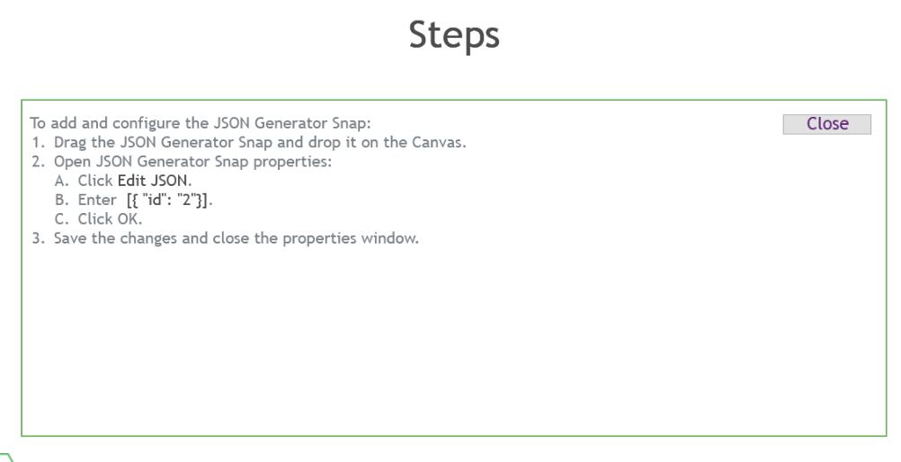

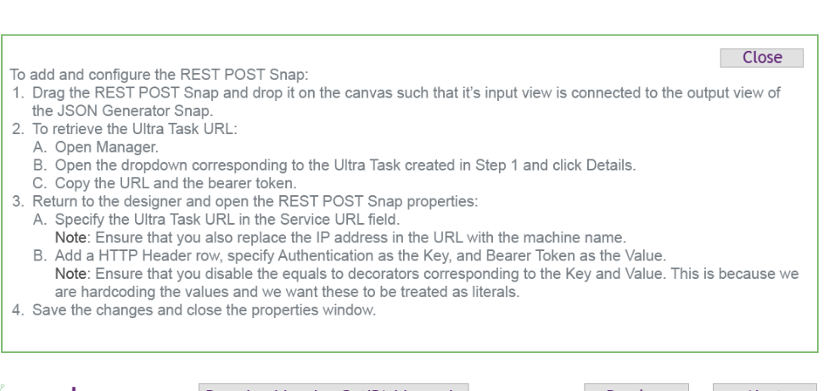

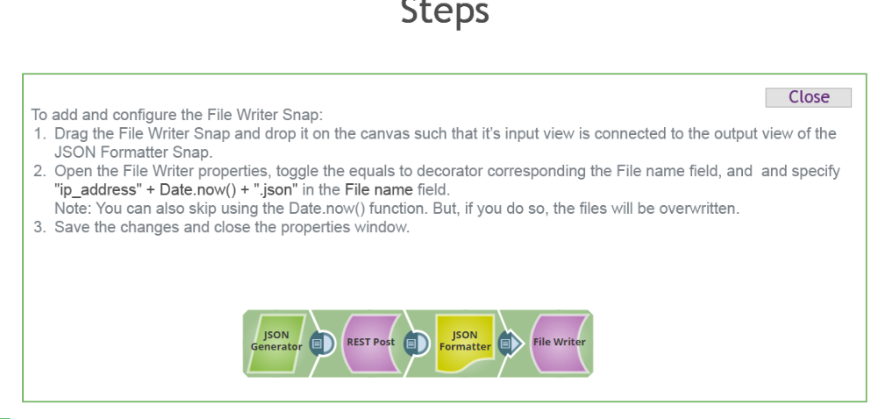

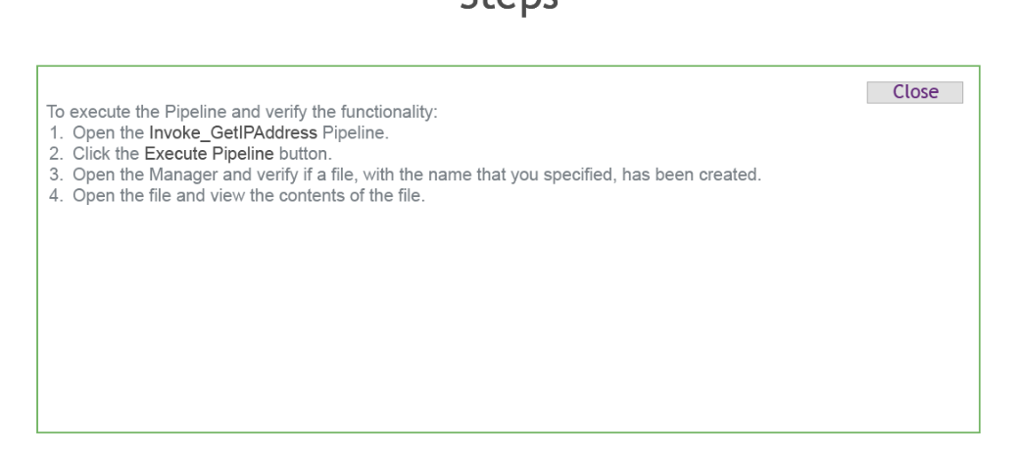

Hands-on –2

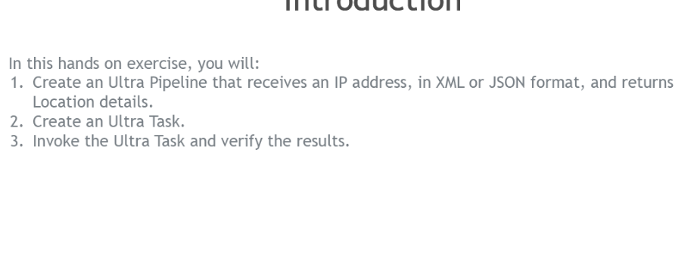

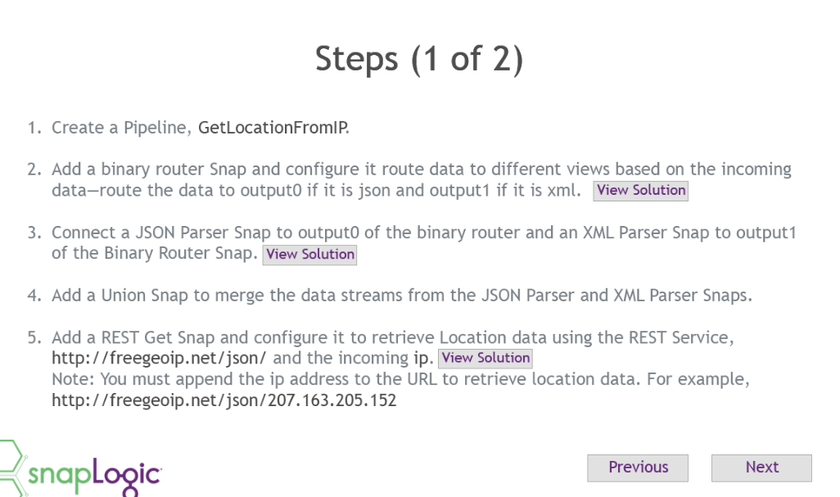

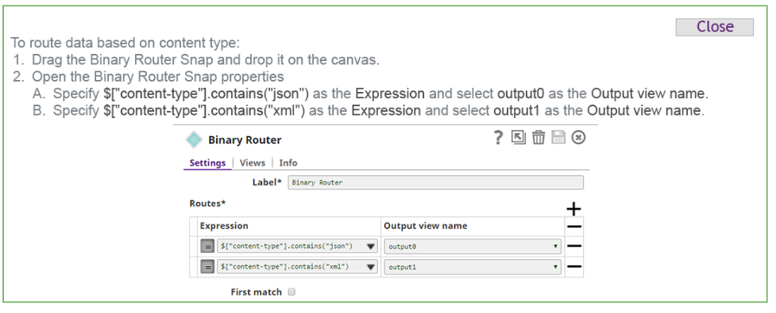

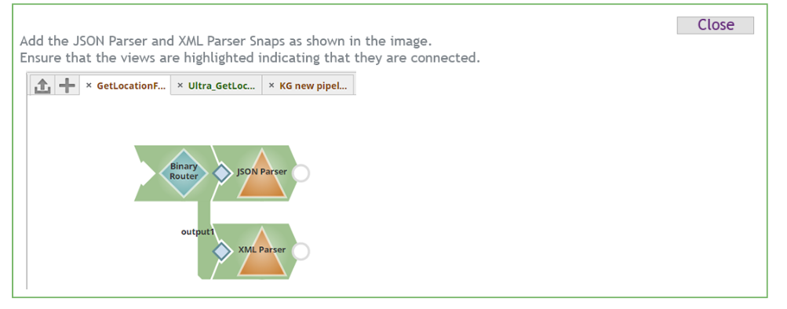

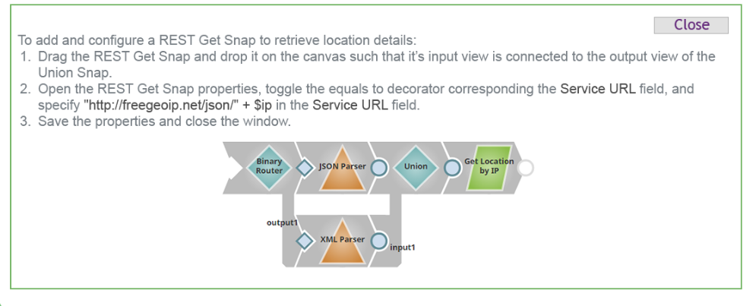

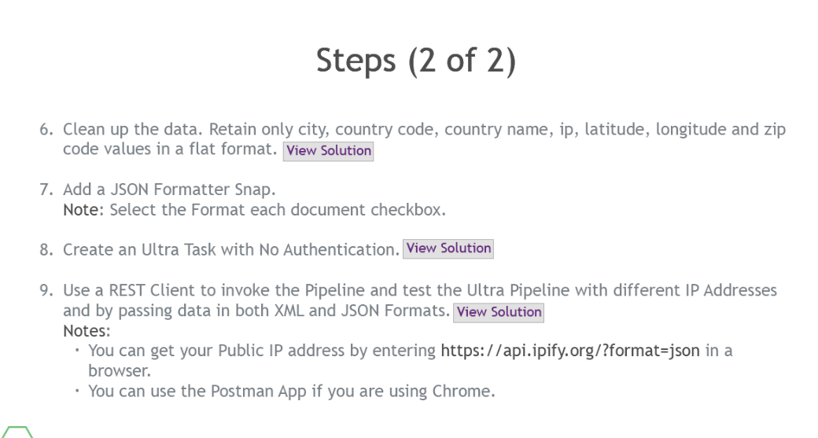

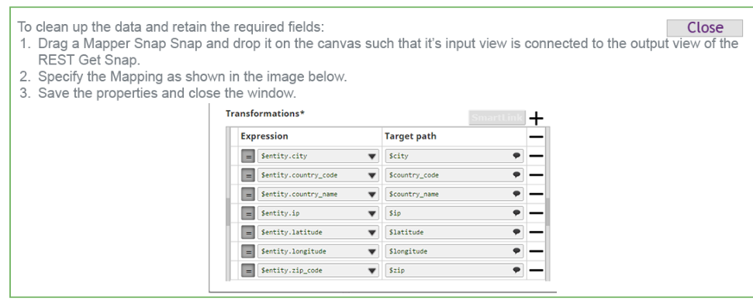

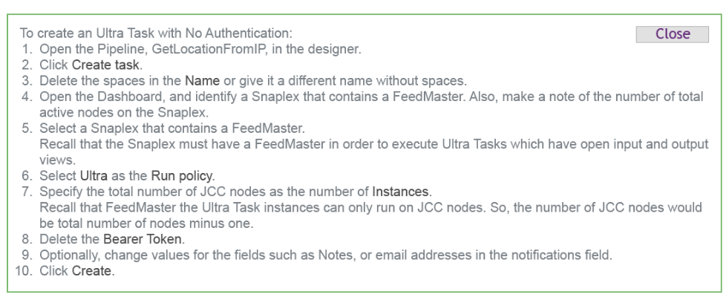

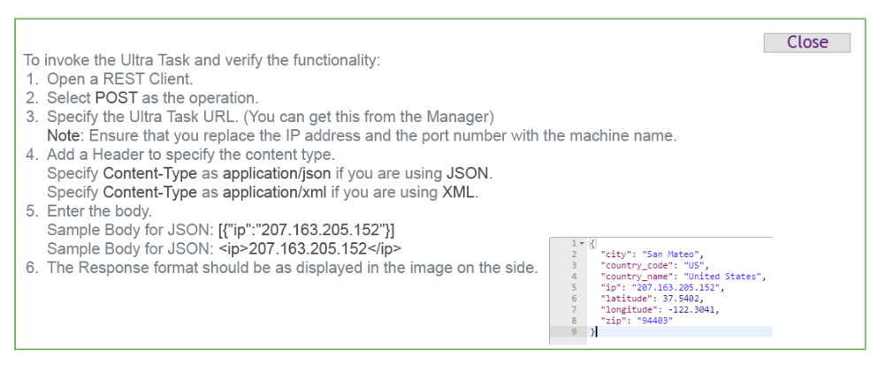

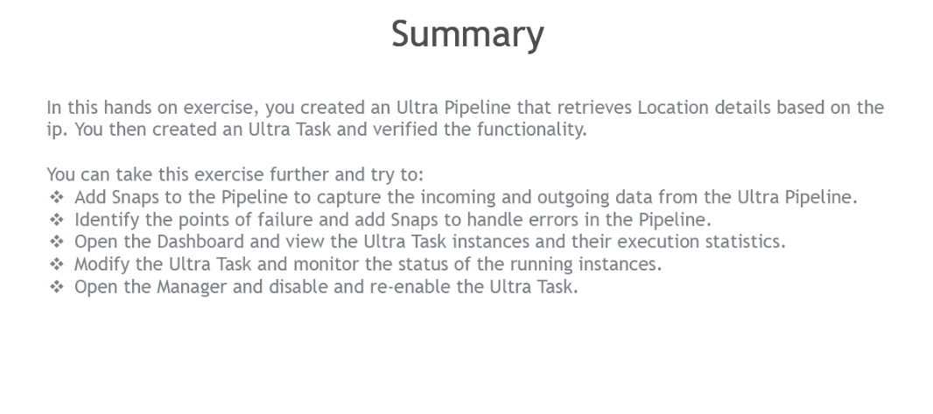

----------------------------------------------------------------------------------------------------------------

APACHE NIFI

1. DATA FLOW- moving data from source to destination. Data can be csv,json,html that can be any sensor data
2. DATA PIPELINE – movement of data with transformation from source to destination

Data deals with 4V – velocity,volume,variety,varacity

--------------------------------------------------------------------------------------------------------------------------

**local login filter module in mendix**

This module allows control over who can login using local accounts. If SSO is your main way of logging in, this can be used to deny access (for all or particular groups) to those who are trying to login using built-in credentials.

---------------------------------------------------------------------------------------------------------------------

#### **Gantt chart**

#### **A Gantt chart is a** [**project management**](https://www.clearpointstrategy.com/project-management/) **tool used for charting the various activities associated with that project against a specific timeline. The chart provides a visual guide to start and end dates on different activities, statuses of the activities, and whether or not they are complete.**

Gantt charts can also show how different activities are related to one another and how the completion or delay of one milestone might impact the others. With one quick glance, you can see how a project is performing relative to the allotted timeline and budget. Because Gantt charts provide so much information in a simple visual, they can be incredibly useful for both project managers and key stakeholders alike.



substring($Product_Variable,0 ,(length($Product_Variable)-1)) + ','

replaceAll($Variable + substring($Order_Variable,1),'_','')

replaceAll($Product_Variable,'[\[\]]', '') +',' - remove [] from the string

// XPath<ProductTeamDetails> xpath = XPath.create(getContext(), ProductTeamDetails.class);

// List<ProductTeamDetails> ProductList = xpath.all();

//

// XPath<OrdersDetails> xpath1 = XPath.create(getContext(), OrdersDetails.class);

// List<OrdersDetails> OrdersDetailsList = xpath1.all();

JSONArray jsonArray = new JSONArray(this.inputjson);

JSONArray parent = new JSONArray();

JSONArray child = new JSONArray();

JSONArray finalarray = new JSONArray();

for (int i = 0; i < jsonArray.length(); i++) {

JSONObject jsonObj = jsonArray.getJSONObject(i);

if (jsonObj.get("type").equals("project")) {

parent.put(jsonObj);

}

if (jsonObj.get("type").equals("task")) {

child.put(jsonObj);

}

}

for (int i = 0; i < parent.length(); i++) {

JSONObject jsonObj = parent.getJSONObject(i);

finalarray.put(jsonObj);

for (int k = 0; k < child.length(); k++) {

JSONObject jsonObj1 = child.getJSONObject(k);

if (jsonObj.get("id").equals(jsonObj1.get("project"))) {

finalarray.put(jsonObj1);

}

}

}

return finalarray.toString();

Retrieve from db in java action

XPath<Entity> xpath = XPath.create(getContext(), Entity.class) .eq( Entity.MemberNames.Name , Name ) .and() .eq(Entity.MemberNames.Type,Type.ABC);

List<Entity> companies = xpath.all();

To iterate

ProductList.stream().forEach((product) -> { logic }); //product is an each obj in a list

